Beet harvest check list-

State Permit- <https://mn.gotpermits.com>

Home page of Minnesota SUPERLOADS-

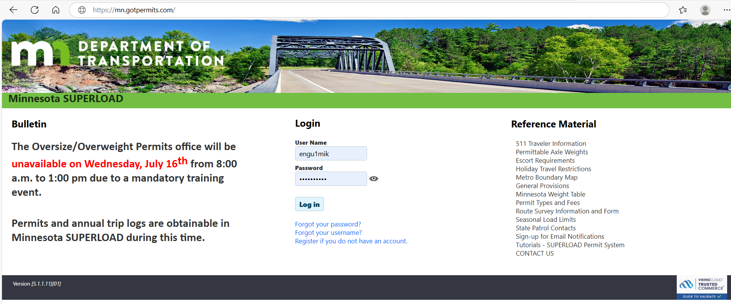



On home page above under Reference Material left side bottom marked in yellow is video tutorials which will bring you to this page allowing you to learn how to set up new account or order a permit.

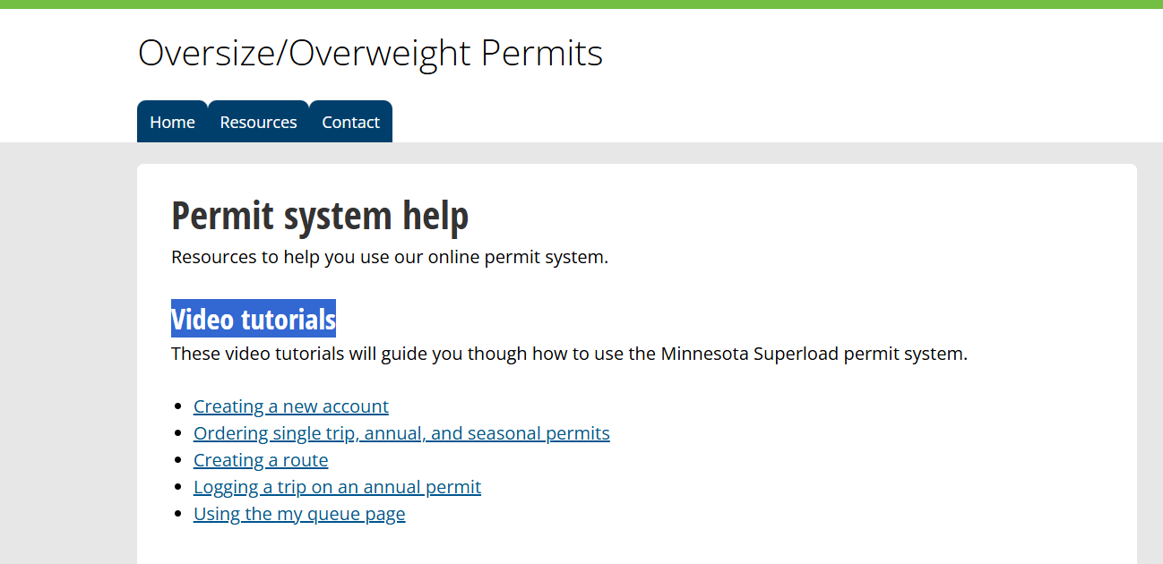

Types of Permits

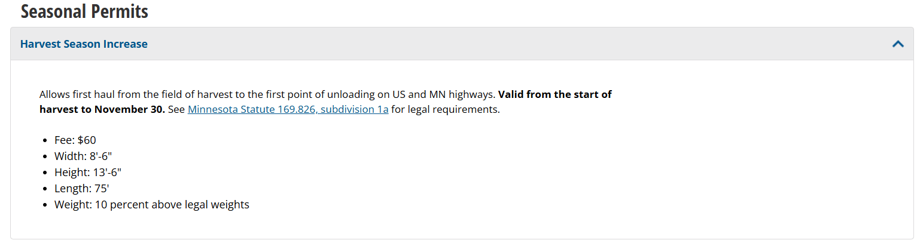

Harvest Seasonal Permit allows 10% above legal weights

## Subd. 1a.Harvest season increase amount; permit.

The limitations provided in sections [169.823](https://www.revisor.mn.gov/statutes/cite/169.823) to [169.829](https://www.revisor.mn.gov/statutes/cite/169.829) are increased by ten percent from the beginning of harvest to November 30 each year for the movement of sugar beets, carrots, and potatoes from the field of harvest to the point of the first unloading. Transfer of the product from a farm vehicle or small farm trailer, within the meaning of chapter 168, to another vehicle is not considered to be the first unloading. A permit issued under section [169.86, subdivision 1](https://www.revisor.mn.gov/statutes/cite/169.86#stat.169.86.1), paragraph (a), is required. The commissioner shall not issue permits under this subdivision if to do so will result in a loss of federal highway funding to the state.

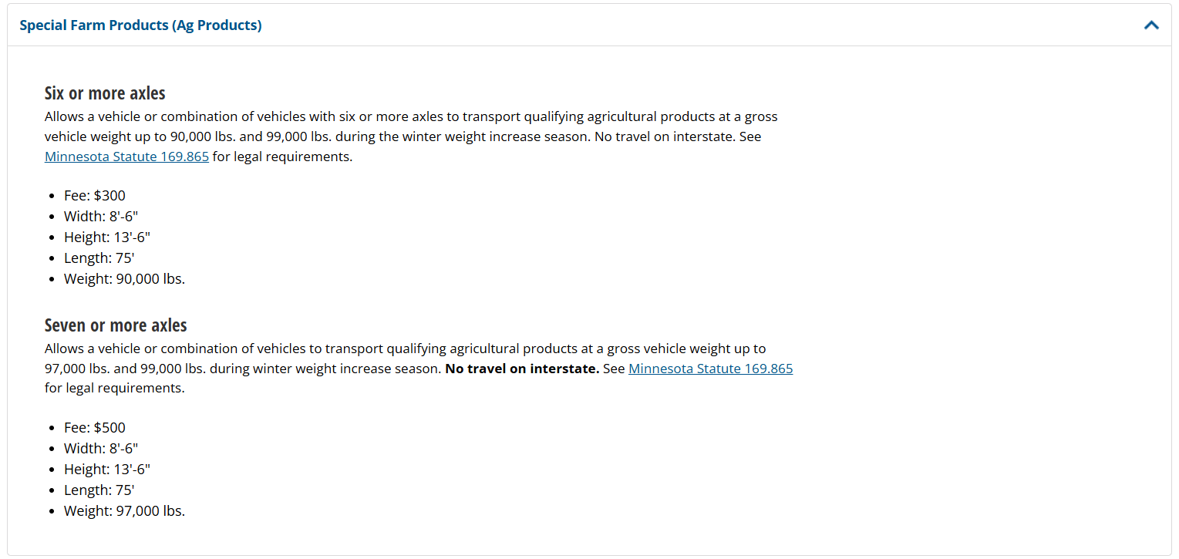

# 169.865 SPECIAL FARM PRODUCTS PERMITS.

## Subdivision 1.

[**§**](https://www.revisor.mn.gov/statutes/cite/169.865#stat.169.865.1a)

## Subd. 1a.Definition.

For purposes of this section, "qualifying agricultural products" means:

(1) agricultural crops, including but not limited to corn, soybeans, oats, grain, and by-products of agricultural crops;

(2) livestock, including but not limited to cattle, hogs, and poultry;

(3) food crops, including but not limited to sugar beets, potatoes, carrots, and onions;

(4) fluid milk;

(5) seed and material used for or in livestock and poultry feed;

(6) livestock manure; and

(7) raw or processed grass seed.

## Subd. 1b.Six-axle vehicles.

(a) A road authority may issue an annual permit authorizing a vehicle or combination of vehicles with a total of six or more axles to haul qualifying agricultural products and be operated with a gross vehicle weight of up to:

(1) 90,000 pounds; and

(2) 99,000 pounds during the period set by the commissioner under section [169.826, subdivision 1](https://www.revisor.mn.gov/statutes/cite/169.826#stat.169.826.1).

(b) Notwithstanding subdivision 3, paragraph (a), clause (4), a vehicle or combination of vehicles operated under this subdivision and transporting only sealed intermodal containers may be operated on an interstate highway if allowed by the United States Department of Transportation.

(c) The fee for a permit issued under this subdivision is $300, or a proportional amount as provided in section [169.86, subdivision 5](https://www.revisor.mn.gov/statutes/cite/169.86#stat.169.86.5).

## Subd. 2.Seven-axle vehicles.

(a) A road authority may issue an annual permit authorizing a vehicle or combination of vehicles with a total of seven or more axles to haul qualifying agricultural products and be operated with a gross weight of up to:

(1) 97,000 pounds; and

(2) 99,000 pounds during the period set by the commissioner under section [169.826, subdivision 1](https://www.revisor.mn.gov/statutes/cite/169.826#stat.169.826.1).

(b) Drivers of vehicles operating under this subdivision must comply with driver qualification requirements adopted under section [221.0314, subdivisions 2](https://www.revisor.mn.gov/statutes/cite/221.0314) to 5, and Code of Federal Regulations, title 49, parts 40 and 382, unless exempt under section [221.031](https://www.revisor.mn.gov/statutes/cite/221.031), subdivision 2c.

(c) The fee for a permit issued under this subdivision is $500, or a proportional amount as provided in section [169.86, subdivision 5](https://www.revisor.mn.gov/statutes/cite/169.86#stat.169.86.5).

## Subd. 3.Requirements; restrictions.

(a) A vehicle or combination of vehicles operating under this section:

(1) is subject to axle weight limitations under section [169.824, subdivision 1](https://www.revisor.mn.gov/statutes/cite/169.824#stat.169.824.1);

(2) is subject to seasonal load restrictions under section [169.87](https://www.revisor.mn.gov/statutes/cite/169.87);

(3) is subject to bridge load limits posted under section [169.84](https://www.revisor.mn.gov/statutes/cite/169.84);

(4) may only be operated on paved streets and highways other than interstate highways;

(5) may not be operated with loads that exceed the manufacturer's gross vehicle weight rating as affixed to the vehicle, or other certification of gross vehicle weight rating complying with Code of Federal Regulations, title 49, sections 567.4 to 567.7;

(6) must be issued a permit from each road authority having jurisdiction over a road on which the vehicle is operated, if required;

(7) must comply with the requirements of section [169.851, subdivision 4](https://www.revisor.mn.gov/statutes/cite/169.851#stat.169.851.4); and

(8) must have brakes on all wheels.

(b) The percentage allowances for exceeding gross weights if transporting unfinished forest products under section [168.013, subdivision 3](https://www.revisor.mn.gov/statutes/cite/168.013#stat.168.013.3), paragraph (b), or for the first haul of unprocessed or raw farm products or unfinished forest products under section [168.013, subdivision 3](https://www.revisor.mn.gov/statutes/cite/168.013#stat.168.013.3), paragraph (d), clause (3), do not apply to a vehicle or combination of vehicles operated under this section.

(c) Notwithstanding paragraph (a), clause (4), a vehicle or combination of vehicles hauling fluid milk under a permit issued by the commissioner of transportation may also operate on interstate highways as provided under United States Code, title 23, section 127.

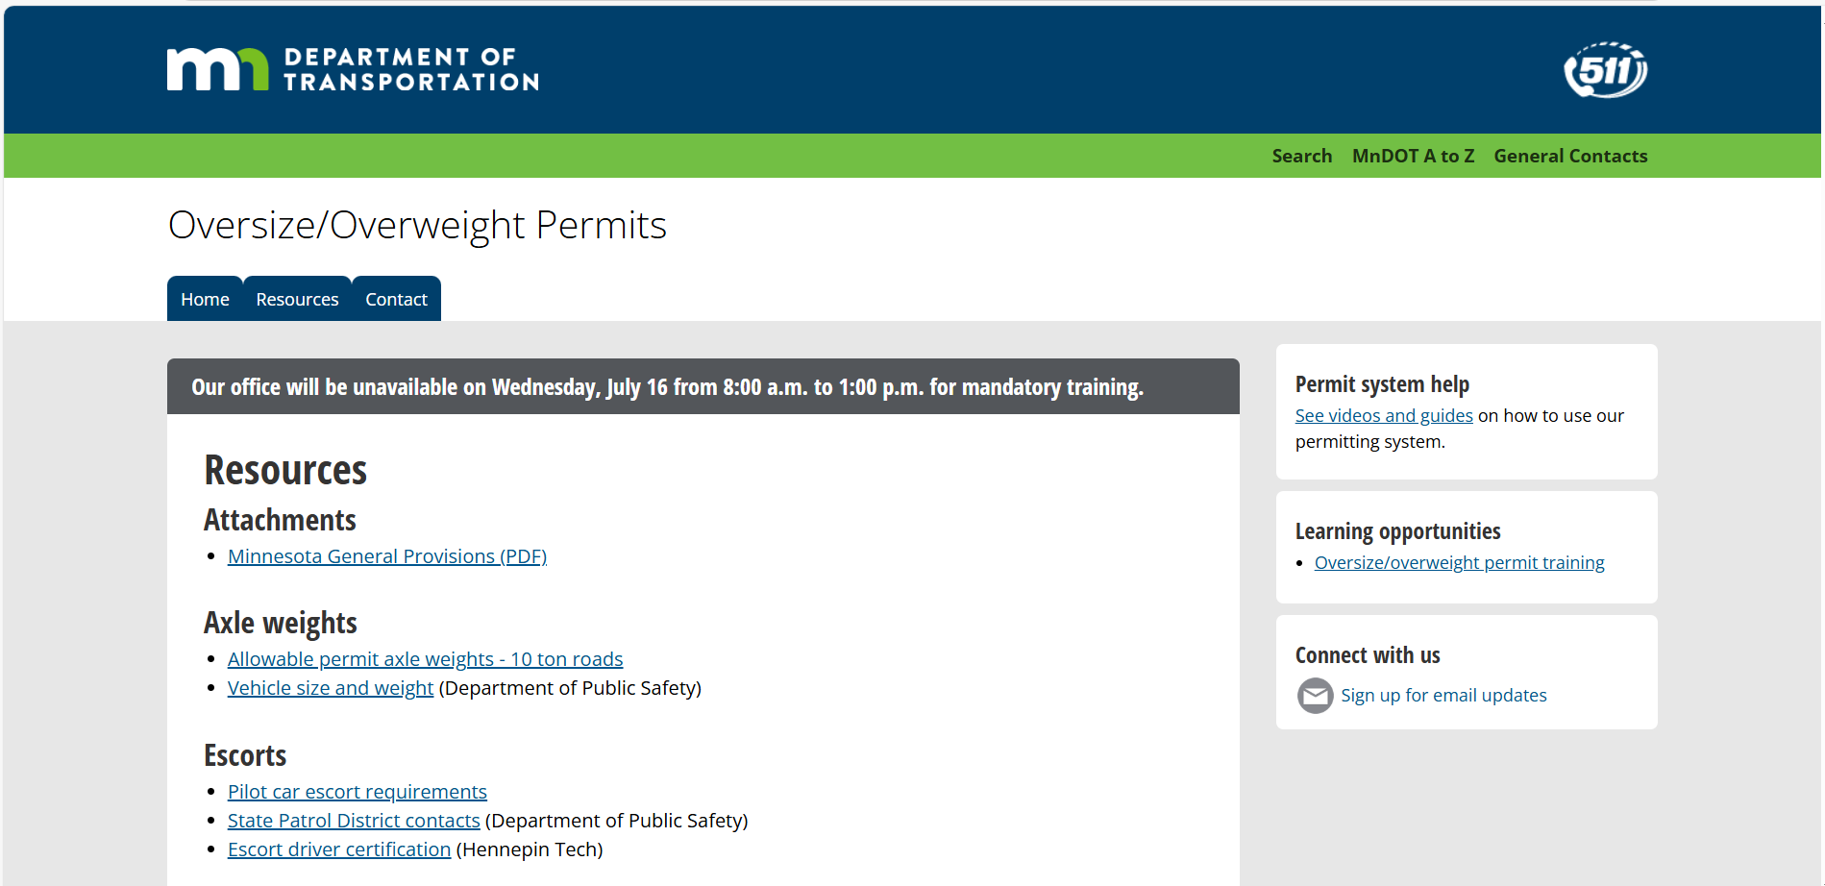

## Creating a new account

<https://youtu.be/gf24gIeRitQ?si=dPuFRDJz7ARycpvV>

## Permits Ordering single trip, annual, and seasonal

<https://youtu.be/1YM32rboCBI>

Lt Mike Engum

[Mike.Engum@state.mn.us](mailto:Mike.Engum@state.mn.us)

218-398-3800